TITLE OF THE ARTICLE (MAX. 25 WORDS)

Author’s name and surname
ORCID Number
Affiliation (University or Institute, Faculty or School, City, Country)

Author’s name and surname
ORCID Number
Affiliation (University or Institute, Faculty or School, City, Country)

ABSTRACT. The abstract should have a maximum of 150 words.

KEYWORDS: keyword one, keyword two. (The article must include a minimum of five keywords and a maximum of seven keywords)

TITLE OF THE ARTICLE

ABSTRACT.

Note: The abstract should have a maximum of 150 words.

Keywords: keyword one, keyword two. (The article must include a maximum of five keywords)

1. INTRODUCTION

This template can be used to create your article in Microsoft Word. We recommend using the Microsoft Word formula editor. Include a brief paragraph at the end of this section describing the structure of your article.

2. METHODOLOGY

Include the research type, design, and scope. Detail the procedures for selecting experimental materials and describe methods, equipment, and procedures thoroughly. Mathematical procedures and statistical methods should be described in detail.

3. RESULTS

Present results in a logical sequence in both text and visual elements (tables and figures). Include figures in source software format or as high-resolution images (e.g., JPG format of at least 600 DPI). Indicate the data source when applicable.

Figure 1
2-Operator Cell Design – Family Size Pizza
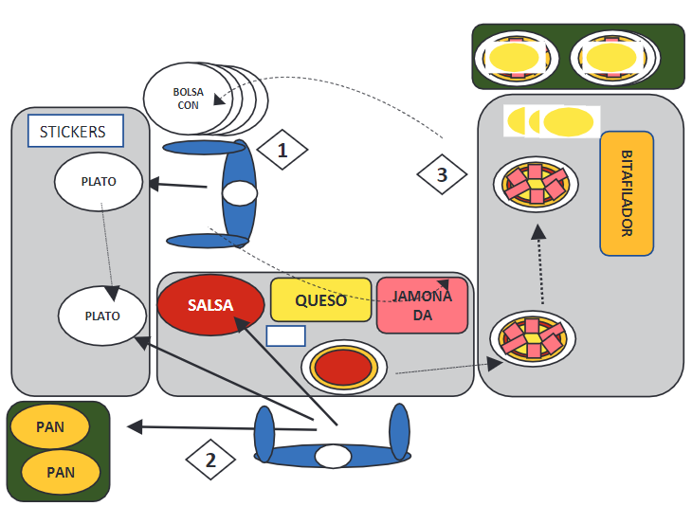
Note. Adapted from “Improving lead time and productivity in the pizza assembly process by applying lean manufacturing tools,” by B. Escudero-Santiago, 2020, Ingeniería Industrial, 39, p. 51–72 (https://doi.org/10.26439/ing.ind2020.n039.4915)

Bolsa con | Bag with
Plato | Plate
Pan | Dough
Bitafilador | Dough portioner
Salsa | Sauce
Queso | Cheese
Jamon | Ham

Table 1
Saaty scale
Score | Definition | Explanation
1 | Equal importance | The two elements contribute equally to the objective.
3 | Moderate importance | Experience and judgment slightly favor one element over the other.
5 | Strong importance | Experience and judgment strongly favor one element over the other.
7 | Very Strong or Demonstrable Importance | One element is strongly preferred over the other, and this preference can be demonstrated in practice.
9 | Extreme Importance | The evidence overwhelmingly favors one alternative over the other.
2,4,6,8 | Intermediate Values | Used when interpolation is needed between adjacent scale values because there is no precise term to describe the relationship between elements.
Note. Adapted from “Supplier selection under a multiple sourcing strategy in a metalworking company” by V. A. Mortara & L. B. Tabone, 2020, Ingeniería Industrial, 40, p. 91–112 (https://doi.org/10.26439/ing.ind2021.n40.4809)

In all cases, the source of the data must be indicated.

4. DISCUSSION

5. CONCLUSIONS

Present your findings, recommendations, or suggestions for future work in this section.

The article length must not exceed 6,000 words (from the introduction through the conclusions)
*A maximum of three color figures is permitted.

CONFLICTS OF INTEREST
Example:
The authors declare no conflicts of interest.
AUTHOR CONTRIBUTIONS
Example:
Edwin González: Writing – original draft, writing – review and editing, conceptualization, data curation, methodology, investigation. Javier Sanchis: Writing – review and editing, supervision, conceptualization, visualization. José Vicente Salcedo: Writing – review and editing, supervision. Miguel Andrés Martínez: Supervision, software.

6. REFERENCES

Conover, W. J. (1980). Practical Nonparametric Statistics. John Wiley & Sons.
Huanca, T., Apaza, N., & Gonzáles, M. (2007). Experiencia del INIA en el fortalecimiento del Banco de germoplasma de camélidos sudamericanos. In XX Reunión ALPA, XXX Reunión APPA-Cusco-Perú (pp. 34–41). http://www.bioline.org.br/pdf?la07051
Suárez-Barraza, M.F., Ramis-Pujol, J., & Kerbache, L. (2011). Thoughts on Kaizen and its evolution: three different perspectives and guiding principles. International Journal of Lean Six Sigma, 2(4), 288–308.
Wicki, G. A. (1990). El proceso de ahumado como valor agregado en la producción del Catfish Sudamericano (Rhamdia sapo). Retrieved from: https://docplayer.es/6675262-El-proceso-de-ahumado-como-valor-agregado-en-la-produccion-del-catfish-sudamericano-rhamdia-sapo-gustavo-a-wicki-introduccion.html

References must be submitted in APA format 7th edition, 2020, in alphabetical order and must correspond strictly to the citations included in the article. In the case of references to articles published in journals or conference proceedings, include the DOI if it is present.

This study was not funded by any entity. If the research received funding, indicate the institution name and funding code. Corresponding Author emails in order of appearance: author1@mmm; author2@mmm This is an open access article distributed under the terms of the Creative Commons Attribution 4.0 International license (CC BY 4.0).

