Title of article in English

Patrick Dallasega
https://orcid.org/0000-0001-6120-X620
Faculty of Science and Technology
Free University of Bozen-Bolzano, Italy
patrick.dallasega1@unibz.it

Matteo Mario Savino
https://orcid.org/0000-0002-2244-X558
Professor of Industrial Operations and Industrial Management
University of Sannio, Benevento, Italy
matteo.savino@unisannio.it

Abstract
The abstract should be a brief but comprehensive reflection of your paper. The abstract should indicate the nature and contribution of the study. In particular, the abstract should be autonomous, without abbreviations, formulations, footnotes, or references. Make sure your abstract reads well and is grammatically correct. The abstract should have a maximum of 200 words, and the keyword list should be between 3 and 5 words separated by commas. The number of pages should be between 6 and 8 for research papers in progress, including references (proceedings).

Note: The abstract should have a maximum of 200 words.
Keywords: keyword 1, keyword 2. (The maximum number of keywords required for the proceedings is 5 words)

1. Introduction

Include in this section the importance of the research, as well as the background or status of the problem addressed. Try to include at the end of the section a paragraph briefly describing the parts of your article.

2. Methodology

Include the selection procedures of the experimental material used and detail the methods, equipment, and procedures. Mathematical procedures and statistical methods should be described in detail, as well as participants and validation techniques if applicable.

3. Results

Present findings in a logical sequence, both in the text and in tables and figures. Consider including figures in the format of the source software or a high-resolution image, for example, in jpg format of at least 300 dpi. For tables or figures you may indicate the source from which the data were obtained, if applicable.

Figure 1
Diseño de célula para 2 operarios – pizza tamaño familiar
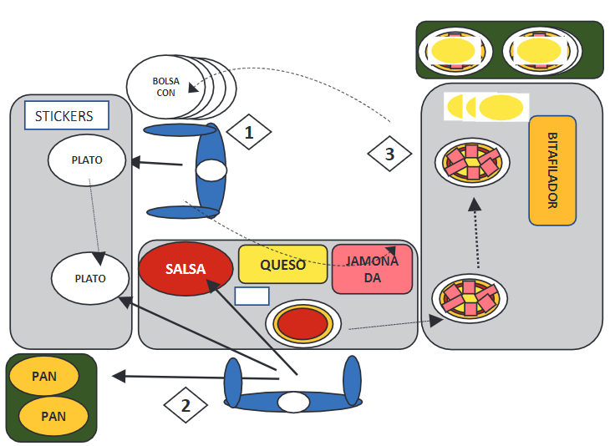
Nota. Adaptado de “Mejora del lead time y productividad en el proceso armado de pizzas aplicando herramientas de lean manufacturing,” por B. Escudero-Santiago, 2020, Ingeniería Industrial, 39, p. 51-72 (https://doi.org/10.26439/ing.ind2020.n039.4915)

Table 1
Algorithmic Response Time

f(n) | 10 | 20 | 30 | 40 | 50
n | 0.00001 seg. | 0.00002 seg. | 0.00003 seg. | 0.00004 seg. | 0.00005 seg.
n2 | 0.0001 seg. | 0.0004 seg. | 0.009 seg. | 0.0016 seg. | 0.0025 seg.
n3 | 0.001 seg. | 0.008 seg. | 0.027 seg. | 0.064 seg. | 0.125 seg.
n5 | 0.1 seg. | 3.2 seg. | 24.3 seg. | 1.7 min. | 5.2 min.
2n | 0.001 seg. | 1 seg. | 17.9 min. | 17.7 días | 35.1 años

Note. Experiment results according to Aguilar’s methodology (2013).

4. Discussion

Discuss your results contrasting them with the current state of knowledge. You may also indicate the limitations, recommendations or new lines of research that open up in the future with your research.

5. Conclusions

Include in this section your conclusions, briefly and trying to answer the research question. If the research is funded, indicate the source of funding and/or possible conflicts of interest.

6. References

References should be presented in APA 7th edition 2020 format, in alphabetical order and should strictly correspond to the citations included in the article. In the case of references to articles published in journals or conference proceedings, include the DOI if available. (15-20 references)

Examples:

Conover, W. J. (1980). Practical Nonparametric Statistics. New York: John Wiley & Sons

Huanca, T., Apaza, N. y Gonzáles, M. (2007). Experiencia del INIA en el fortalecimiento del Banco de germoplasma de camélidos sudamericanos. In XX Reunión ALPA, XXX Reunión APPA-Cusco-Perú (pp. 34–41). http://www.bioline.org.br/pdf?la07051

Suárez-Barraza, M.F., Ramis-Pujol, J. y Kerbache, L. (2011). Thoughs on Kaizen and its evolution: three different perspectives and guiding principles. International Journal of Lean Six Sigma, 2(4), 288-308.
Wicki, G. A. (1990). El proceso de ahumado como valor agregado en la producción del Catfish Sudamericano (Rhamdia sapo). Obtenido de: https://docplayer.es/6675262-El-proceso-de-ahumado-como-valor-agregado-en-la-produccion-del-catfish-sudamericano-rhamdia-sapo-gustavo-a-wicki-introduccion.html

The content of the entire article, including the abstract and references, should not exceed 7000 words.

